**A HIGH-LEVEL DESIGN DOCUMENT FOR PROFESSIONAL SOCIAL NETWORK LINKEDIN**

**1.INTRODUCTION:**

A High-Level Design (HLD) document for LinkedIn, one of the world's leading professional networking platforms. This document outlines the architectural design and key components of LinkedIn, providing insights into its functionality, structure, and interactions.

**1.1 PURPOSE OF THE DOCUMENT:**

The purpose of this document is to provide a high-level overview of the design and architecture of LinkedIn, focusing on its core features and systems. It aims to guide developers, architects, and stakeholders in understanding the overall structure and functionality of the platform.

**1.2 SCOPE OF THE DOCUMENT:**

The scope of this document encompasses the architectural components, modules, and interactions of LinkedIn, including user authentication, profile management, connections, messaging, content sharing, and recommendation systems.

**1.3 OVERVIEW OF THE SOCIAL MEDIA PLATFORM:**

LinkedIn is a social media platform focused on professional networking and career development. LinkedIn helps professionals connect, collaborate, and grow their careers providing a platform for networking, job searching, and professional development.

**1.4 KEY OBJECTIVES AND GOALS OF THE SYSTEM:**

The key objectives of this document are as follows:

* To describe the high-level architecture of LinkedIn, including its components and interactions.
* To identify the core features and functionalities of LinkedIn and their respective modules.
* To outline the data flow and communication patterns within LinkedIn's systems.
* To provide insights into the scalability, reliability, and performance considerations of LinkedIn's architecture.
* To guide future development efforts and enhancements to LinkedIn's platform.

**2. REQUIREMENTS AND GOALS:**

The requirements and goals for LinkedIn into both functional and non-functional categories in a high-level design.

**2.1 FUNCTIONAL REQUIREMENTS:**

**User Authentication and Authorization:**

* Users should be able to create accounts securely.
* Users should be able to log in using various authentication methods (email/password, social media, etc.).
* Access control mechanisms to ensure users can only view/edit content they have permission for.

**User Profile Management:**

* Users should be able to create and manage their profiles.
* Ability to add/edit personal information, work experience, education, skills, etc.
* Option to upload profile pictures and cover photos.

**Content Creation and Publishing:**

* Users should be able to create posts, articles, and share updates.
* Ability to like, comment, and share content created by others.
* Support for multimedia content (images, videos, documents) sharing.

**Social Interactions:**

* Users can establish connections by sending and accepting requests, enabling direct messaging and content sharing.
* Users can engage with each other's posts and updates through comments, likes, and reactions.
* Users can create and manage events, join interest-based groups, and follow other users to stay updated on their activities.
* Tagging and mentioning other users in content enhances interaction, while endorsements and recommendations help showcase professional credibility.

**Messaging and Notifications:**

* Implement a messaging system for direct communication between users.
* Users should be able to send text messages, multimedia messages, and attachments.
* Support for real-time messaging to enable instant communication.
* Ensure messaging history and conversation threads are accessible and organized.
* Implement a notification system to alert users about relevant activities and updates.
* Notify users about new messages, connection requests, comments, likes, and mentions.
* Support push notifications for mobile devices and browser notifications for web users.
* Ensure notifications are timely, accurate, and actionable, enhancing user engagement and interaction with the platform.

**Search and Discovery:**

* Implement a robust search functionality allowing users to search for other users, jobs, companies, and content.
* Enable keyword-based search with advanced filters for refining results (e.g., location, industry, experience level).
* Ensure search results are relevant, accurate, and ranked based on relevance algorithms.
* Support pagination or infinite scrolling to navigate through large search result sets seamlessly.
* Implement features for users to discover relevant content, connections, and opportunities.
* Display personalized recommendations based on user activity, interests, and connections.
* Enable users to explore trending topics, popular profiles, and industry news.
* Provide curated lists or recommendations for users to follow, join groups, or engage with relevant content.

**2.2 NON-FUNCTIONAL REQUIREMENTS:**

**Performance:**

* The platform should be responsive, with low latency and fast loading times for user interactions.
* Pages, especially user profiles and news feeds, should load quickly to provide a seamless user experience.
* Efficient database queries and caching mechanisms to minimize response times.

**Scalability:**

* The system should be able to handle a growing user base and increasing amounts of data.
* Ability to scale horizontally by adding more servers or resources as needed, especially during peak usage times.

**Security:**

* All user data should be encrypted during transmission and storage to protect confidentiality.
* Protection against common security threats such as cross-site scripting (XSS), cross-site request forgery (CSRF), and SQL injection.
* Regular security audits and updates to ensure compliance with industry standards and regulations.

**Availability:**

* The platform should be available 24/7 with a high level of reliability.
* Redundancy measures, such as load balancers and failover systems, to ensure continuity of service in case of hardware or software failures.
* Effective disaster recovery strategies to minimize downtime in case of catastrophic events.

**Reliability:**

* Use reliable storage solutions and data replication mechanisms to ensure data integrity and availability.
* Implement backup and recovery procedures to prevent data loss and corruption.
* Maintain consistent and predictable performance under varying loads and usage patterns.
* Conduct performance testing and capacity planning to ensure the platform can handle peak loads without degradation.

**Usability:**

* Design an intuitive and user-friendly interface that is easy to navigate for users of all technical backgrounds.
* Ensure clear and consistent layout and navigation elements throughout the platform.
* Ensure accessibility for users with disabilities by adhering to accessibility standards such as WCAG (Web Content Accessibility Guidelines).
* Provide alternative text for images, keyboard navigation, and other accessibility features.
* Allow users to customize their experience by adjusting settings, preferences, and notification preferences.
* Provide options for users to personalize their profiles, news feeds, and other aspects of the platform.

**3.** **ASSUMPTIONS AND PREREQUISITES**:

**3.1 TECHNOLOGY STACK:**

**1.Backend Technologies**:

* **Programming Languages:** Java or Node.js are commonly used for building the backend logic.
* **Frameworks:** Spring Boot (Java), provide robust frameworks for developing scalable web applications.

**2.Frontend Technologies:**

* **HTML/CSS/JavaScript:** Standard web technologies used for building user interfaces and adding interactivity.
* **JavaScript Frameworks/Libraries:** React.js and Angular are popular choices for building dynamic and responsive frontend interfaces.
* **CSS Frameworks:** Bootstrap or Materialize CSS provide pre-designed components and styles for faster frontend development.

**3.Databases:**

* Relational databases like MySQL as well as NoSQL databases like MongoDB are often used to store user data, connections, and other platform information.

**3.2 INFRASTRUCTURE REQUIREMENTS:**

* **Cloud Services:** Amazon Web Services (AWS) provide scalable infrastructure and services for hosting and managing applications.
* **Containerization:** Docker containers may be used for packaging applications and services, while Kubernetes can be used for container orchestration and management.
* **Continuous Integration/Continuous Deployment (CI/CD):** Tools like Jenkins, GitLab CI/CD automate the build, test, and deployment processes, ensuring faster and more reliable software delivery.
* **Authentication and Authorization:** OAuth 2.0 or OpenID Connect may be used for user authentication and authorization.

**3.3 DATA PRIVACY AND COMPLAINCE:**

**Data Encryption:**

* Ensure that sensitive user data, such as passwords and personal information, is encrypted both in transit and at rest to protect it from unauthorized access or interception.

**User Consent Mechanisms:**

* Implement mechanisms to obtain explicit consent from users for data collection, processing, and sharing activities. This includes providing clear explanations of how their data will be used and giving them control over their privacy settings.

**Security Measures:**

* Implement robust security measures to protect user data from unauthorized access, including access controls, firewalls, and intrusion detection systems. Regularly assess and update these measures to address new threats and vulnerabilities.

**Third-Party Compliance:**

* Ensure that third-party service providers and partners adhere to the same data privacy and security standards as the platform itself. This may involve contractual agreements, audits, and ongoing monitoring to verify compliance.

**User Rights and Transparency:**

* Provide users with transparency and control over their data by offering access to their personal information, allowing them to update or correct it, and honoring requests for data deletion or portability.

**4. BUSINESS OVERVIEW:**

**4.1 BUSINESS GOALS AND OBJECTIVES:**

To establish LinkedIn as the premier professional networking platform, facilitating connections, knowledge sharing, and career advancement opportunities.

**Boost User Engagement:**

* Increase time spent per user on the platform by 20% in the next quarter.
* Raise daily active user count by 15% over the next six months.

**Improve User Experience:**

* Enhance platform UI for a 25% increase in user satisfaction within a year.
* Implement personalized content recommendations to drive a 10% engagement increase in the next quarter.

**Expand Membership Base:**

* Grow registered users by 30% within a year.
* Target emerging markets, acquiring 5 million new users in two years.

**Brand Building and Trust:**

* Launch marketing campaigns to raise brand awareness by 20% in a year.
* Combat misinformation and spam for a 15% decrease in reported abuses in six months.

**4.2 TARGET AUDIENCE:**

The target audience refers to the specific groups of people or demographics that a product, service, or platform is designed to reach and engage with. Identifying the target audience is crucial for creating effective strategies and ensuring that the product meets the needs and preferences of its intended users.

**Demographic Information:** This includes age, gender, education level, occupation, income level, geographic location, and any other relevant demographic characteristics.

**Psychographic Information:** This encompasses the attitudes, values, beliefs, interests, lifestyles, and behaviours of the target audience.

**User Needs and Pain Points:** Understanding the specific needs, challenges, and problems that the target audience faces helps in designing solutions that address these pain points effectively.

**Motivations and Goals:** Knowing what motivates the target audience and their goals or aspirations allows for the development of features or content that resonate with them and drive engagement.

**Communication Preferences:** Understanding how the target audience prefers to communicate and consume information (e.g., social media, email, in-person events) helps in designing marketing and outreach strategies.

**4.3 COMPETITIVE ANALYSIS:**

**Identify Competitors:**

* Major competitors include professional networking platforms such as Indeed, Glassdoor, AngelList, and Xing.
* General social media platforms like Facebook and Twitter also compete for professional networking and content sharing.

**Market Position:**

* Assess LinkedIn's market share, user base growth, and penetration in various industries and regions.
* Compare strengths, weaknesses, opportunities, and threats relative to competitors.
* Feature Comparison:
* Evaluate key features like profile customization, job search, networking tools (connections, groups), content publishing, and learning resources (LinkedIn Learning).
* Compare the effectiveness and uniqueness of these features against competitors.

**User Experience Analysis:**

* Analyse the user interface, ease of navigation, and mobile responsiveness of LinkedIn compared to competitors.
* Assess user engagement metrics and retention rates to gauge platform satisfaction.

**5. HIGH-LEVEL DESIGN:**

**5.1 ARCHITECTURAL OVERVIEW:**

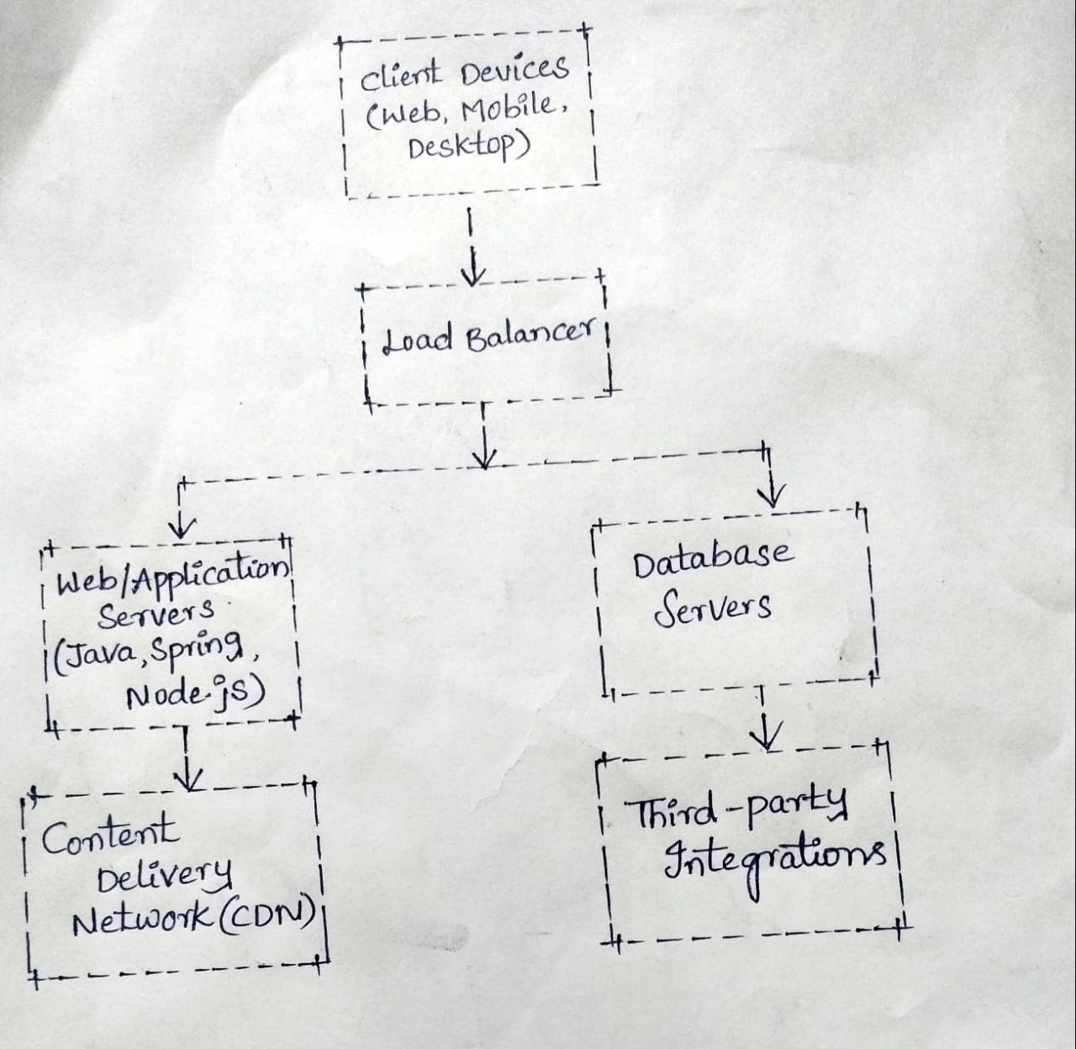

**SYSTEM COMPONENTS:**

**User Interface (UI):**

* The user interface components include web pages, mobile app screens, and desktop interfaces that users interact with to access LinkedIn's features and functionalities.

**Authentication and Authorization:**

* This component manages user authentication, allowing users to log in securely and access their accounts. It also handles authorization to control access to different features and data based on user roles and permissions.

**Profile Management:**

* The profile management component allows users to create and update their profiles, including personal information, work experience, education, skills, and endorsements.

**Networking and Connections:**

* This component facilitates networking and connections between users, allowing them to connect with colleagues, professionals, and industry peers. It includes features such as sending connection requests, accepting invitations, and managing connections.

**Content Management:**

* The content management component enables users to create, publish, and interact with various types of content, including posts, articles, videos, and documents. It includes features for composing, editing, sharing, and engaging with content.

**Messaging and Communication:**

* This component provides messaging and communication features for users to send messages, engage in conversations, and collaborate with connections. It includes features such as messaging, chat, groups, and discussions.

**Job Search and Recruitment:**

* The job search and recruitment component allow users to search for job opportunities, apply for positions, and connect with recruiters and hiring managers. It includes features such as job postings, job search filters, and applicant tracking.

**5.2 COMMUNICATION PROTOCOLS:**

**HTTP/HTTPS (Hypertext Transfer Protocol/Secure):**

* Used for communication between clients (web browsers, mobile apps) and LinkedIn's servers for accessing web pages, sending requests, and receiving responses. HTTPS is preferred for secure communication, encrypting data exchanged between clients and servers.

**WebSocket:**

* Used for real-time communication between clients and servers, enabling features such as instant messaging, notifications, and live updates. WebSocket provides full-duplex communication channels over a single TCP connection, allowing for efficient bi-directional data transfer.

**OAuth 2.0 (Open Authorization):**

* Used for user authentication and authorization, allowing users to securely log in to their LinkedIn accounts and grant permissions to third-party applications. OAuth 2.0 facilitates delegated access, enabling LinkedIn to verify user identity and authorize access to protected resources without exposing user credentials.

**REST (Representational State Transfer):**

* Used for communication between clients and LinkedIn's servers for accessing and manipulating resources, such as user profiles, posts, and messages. RESTful APIs (Application Programming Interfaces) provide a standardized approach for interacting with LinkedIn's services using HTTP methods (GET, POST, PUT, DELETE) and resource URIs (Uniform Resource Identifiers).

**TCP/IP (Transmission Control Protocol/Internet Protocol):**

* Used as the underlying communication protocol for transmitting data packets between clients and servers over the internet. TCP/IP provides reliable, connection-oriented communication for ensuring data integrity and delivery.

**5.2 APPLICATION DESIGN:**

**USER-INTERFACE DESIGN:**

**Homepage:**

* Upon logging in, users are greeted with a personalized homepage.
* The homepage includes a news feed displaying updates from connections, companies followed, and relevant industry news.
* A search bar at the top allows users to search for people, companies, jobs, and content.

**Profile Page:**

* Users have a profile page that showcases their professional information, such as work experience, education, skills, and endorsements.
* They can customize their profile with a profile picture, cover photo, and summary.
* Users can also see who has viewed their profile and have the option to connect with them.

**Connections:**

* Users can connect with other professionals in their network.
* The connections page displays a list of current connections and suggestions for new connections based on mutual connections, industry, and interests.
* Users can send connection requests and accept or reject incoming requests.

**Messaging:**

* The messaging feature allows users to communicate with their connections.
* Users can send text messages, share files, and engage in group conversations.
* Messages can be organized into threads for better management.

**Jobs and Recruitment:**

* LinkedIn provides a platform for job seekers and recruiters.
* Users can search for job listings based on criteria such as location, industry, and experience level.
* Companies can post job openings and manage applications through the platform.
* Content Sharing:
* Users can share articles, blog posts, and other content relevant to their professional interests.
* They can like, comment on, and share content posted by their connections.
* The platform includes features for creating and publishing long-form articles.

**Notifications:**

* Users receive notifications for actions such as connection requests, messages, profile views, and mentions.
* Notifications are displayed prominently on the platform and can be managed in the notification center.

**Settings and Privacy:**

* Users have control over their privacy settings, including who can view their profile and contact them.
* They can also manage email preferences, account security, and other settings from the account dashboard.

**CLIENT-SERVER INTERACTION:**

The basic flow of client-server interaction in LinkedIn, focusing on login, fetching homepage data, performing actions, and receiving real-time updates.

**CACHING STRATEGY:**

* Caching plays a crucial role in optimizing performance and scalability. The platform can implement a caching strategy at various levels to reduce database load and improve response times.
* At the server level, LinkedIn can utilize a distributed caching system such as Redis or Memcached to cache frequently accessed data, such as user profiles, connections, and recent updates. This caching layer helps reduce the number of databases queries and speeds up the retrieval of commonly accessed information.
* Furthermore, caching can be employed at the client-side using techniques like browser caching and local storage to store temporary data and minimize the need for frequent network requests.
* By implementing an effective caching strategy, LinkedIn can enhance user experience, improve platform responsiveness, and handle increased traffic more efficiently.

**5.3** **INTEGRATION POINTS:**

**Third-party Integrations:**

* In a high-level design (HLD) for a social media platform like LinkedIn, third-party integrations play a vital role in expanding functionality and enhancing user experience.
* These integrations can include services such as authentication through platforms like Google or Facebook, enabling users to sign in with their existing accounts seamlessly.
* Another essential integration is with job boards and recruitment platforms, enabling seamless job postings, applications, and candidate sourcing.
* Implementing these third-party integrations strategically can enrich the social media platform's ecosystem, increase user engagement, and provide valuable features to users without the need to develop them from scratch.

**API Design:**

* In the high-level design (HLD) for the LinkedIn API Design, simplicity and effectiveness are key.
* The API should be designed to facilitate seamless integration with third-party applications while providing developers with easy access to LinkedIn's features.
* Authentication mechanisms like OAuth 2.0 should be employed to ensure secure access to user data.
* Pagination, filtering, and sorting capabilities should be provided for efficient data retrieval. Error handling should be robust, with informative error messages and status codes.
* Comprehensive documentation should accompany the API, detailing endpoints, request/response formats, authentication methods, rate limits, and usage examples, to guide developers in utilizing the API effectively.

**5.4 SECURITY DESIGN:**

**Authentication and Authorization Mechanisms:**

* Authentication and Authorization mechanisms in LinkedIn ensure that users can securely access and interact with the platform while safeguarding their data and privacy.
* LinkedIn uses OAuth 2.0 as the primary authentication mechanism. When a user attempts to log in to a third-party application using their LinkedIn credentials, the application redirects the user to LinkedIn's authorization server.
* LinkedIn employs a role-based access control (RBAC) model for authorization, determining what actions users are allowed to perform within the platform based on their roles and permissions.

**Data Encryption:**

**Transport Layer Security (TLS):**

* LinkedIn uses TLS to encrypt data transmitted between users' devices and its servers. TLS ensures that data sent over the internet is encrypted and cannot be intercepted by unauthorized parties.
* All communication between the client (e.g., web browser or mobile app) and LinkedIn's servers is encrypted using TLS, preventing eavesdropping and man-in-the-middle attacks.

**Data Encryption at Rest:**

* LinkedIn encrypts data stored on its servers to protect it from unauthorized access. This includes user profiles, messages, connections, and other sensitive information.
* Encryption algorithms like AES (Advanced Encryption Standard) are used to encrypt data before storing it in the database. Access to the encryption keys is tightly controlled to prevent unauthorized decryption of data.

**End-to-End Encryption for Messages:**

* LinkedIn may implement end-to-end encryption for messages exchanged between users. With end-to-end encryption, messages are encrypted on the sender's device and can only be decrypted by the intended recipient.
* Even LinkedIn's servers cannot access the contents of encrypted messages, ensuring user privacy and confidentiality.

**Key Management:**

* Proper key management is essential for effective data encryption. LinkedIn securely manages encryption keys, rotating them regularly and storing them in hardware security modules (HSMs) or other secure key management systems.
* Access to encryption keys is restricted to authorized personnel, and strong authentication measures are in place to prevent unauthorized access.

**6. APPLICATION MODULES:**

**User Management Module:**

* Responsible for user authentication, registration, and profile management.
* Handles user data, including personal information, contact details, and preferences.
* Manages user roles and permissions for accessing different features and resources within the platform.

**Content Management Module:**

* Enables users to create, publish, and interact with various types of content, including posts, articles, comments, and media uploads.
* Supports content moderation, reporting, and curation to maintain quality and relevance within the platform.
* Includes features for content discovery, recommendation, and engagement tracking.

**Messaging Module:**

* Provides messaging and communication capabilities for users to interact privately with their connections.
* Supports one-on-one and group messaging, file sharing, and real-time notifications for new messages.
* Ensures message privacy and security through encryption and access control mechanisms.

**Social Interaction Module:**

* Enables users to connect and engage with other professionals on the platform. Users can send and receive connection requests to establish professional relationships, expand their network, and discover opportunities.
* Users can engage with content shared by their connections through likes, comments, and shares. Private messaging features enable direct communication between users, fostering collaboration and networking.

**Search and Discovery Module:**

* Users can conduct searches based on various criteria such as industry, location, job title, skills, and connections.
* It offers advanced filters and sorting options to refine search results and discover relevant profiles, posts, articles, and job listings.
* Users receive personalized recommendations and suggestions based on their profile, interests, and activity.

**7. TRANSACTIONS AND USER FLOWS:**

**User Registration and Authentication Flow:**

* The user registration process on LinkedIn begins with the user providing basic information like name, email, and password.
* To log in, they enter their email and password, possibly with two-factor authentication. Once authenticated, LinkedIn manages their session, allowing access until logout. For password recovery, users provide their email, receive a reset link, and set a new password.

**Profile setup Flow:**

* After registering on LinkedIn, users are guided through profile setup. They add details like education, work experience, skills, and a profile picture. LinkedIn may provide prompts to ensure completeness.

**Content Creation Flow:**

* Content creation begins with users composing a new post, article, or sharing links relevant to their professional interests. They can add text, images, videos, or documents to their post.
* After composing their content, users have the option to preview it before publishing. Once satisfied, they click the "Post" button to share it with their network. Users can also engage with others' content by commenting, liking, or sharing it with their connections.

**Social Interaction Flow:**

* Social interaction on a social media platform involves users engaging with each other's content and profiles.
* Users can like, comment, or share posts to interact with content shared by their connections. They can also send direct messages to connect with others privately.
* Additionally, users can view and interact with profiles by sending connection requests or endorsing skills.

**Messaging Flow:**

* In the messaging flow of a social media platform, users compose messages within the platform's interface, selecting recipients from their connections. Once sent, the platform's messaging service receives and queues the message for delivery.
* Recipients receive real-time notifications for new messages, either through the platform or push notifications if offline. Upon accessing their inbox, recipients view and can interact with the message.
* Read receipts are sent to the sender upon message opening. Recipients can reply, react, or initiate group conversations. Messages are archived for future reference, and users can search for specific conversations. Security measures like encryption and privacy settings ensure message confidentiality.

**Search and Discovery Flow:**

* Users enter keywords or criteria such as names, companies, or skills into the search bar. The platform then returns relevant results, including profiles, posts, jobs, and groups. Users can filter results by various parameters like location, industry, or connection level.
* Users can explore and engage with the suggested content or connections to expand their professional network and discover new opportunities.

**8. FUTURE ENHANCEMENTS:**

**8.1 Feature Roadmap:**

* It focuses on enhancing user experience and fostering professional networking. Skill endorsement improvements will enhance credibility, while advanced search filters will facilitate more targeted connections.
* we'll introduce a portfolio showcase for users to highlight their work and streamline recommendation requests.

**8.2 Technology Upgrades:**

* We're investing in advanced algorithms and machine learning models to personalize content recommendations, ensuring users see the most relevant posts and connections in their feed.
* Security enhancements, including robust encryption protocols and AI-driven threat detection systems, are being deployed to safeguard user data and privacy.

**8.3 Scalability Improvements:**

* We're upgrading our systems and infrastructure to handle increased traffic without slowdowns or downtime. By optimizing how data is stored and accessed, we're ensuring that the platform remains fast and reliable even during peak usage times.

**9. CONCLUSION:**

LinkedIn stands as a vital platform for professionals worldwide, offering opportunities for networking, career advancement, and knowledge sharing. With its robust features, such as profile customization, skill endorsements, and messaging capabilities, LinkedIn continues to facilitate meaningful connections and foster professional growth. Through ongoing innovation and dedication to its community, LinkedIn remains a cornerstone of the professional landscape, connecting talent with opportunities and driving success in the global workforce.